WRITING A FORMULA
OCR GSCE – Thursday 5 November 2020 – Paper 5 (Non-Calculator) Higher Tier
1.
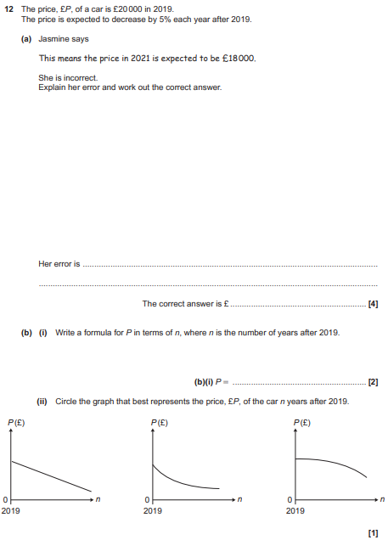

OCR GSCE – Monday 12 November 2018 – Paper 6 (Calculator) Higher Tier
2.
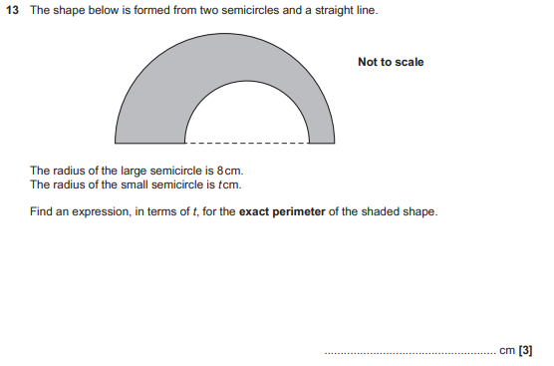

AQA GSCE – Tuesday 19 May 2020 – Paper 1 (Non - Calculator) Higher Tier
3.
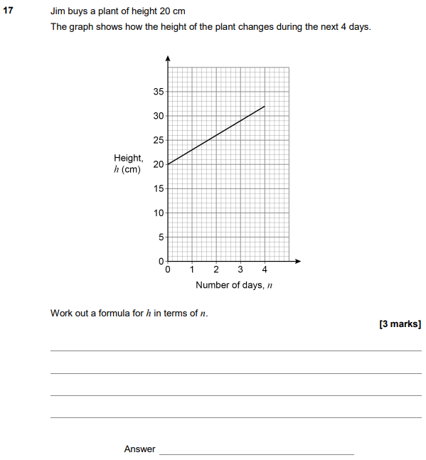

AQA GSCE – Tuesday 21 May 2019 – Paper 1 (Non - Calculator) Higher Tier
4.
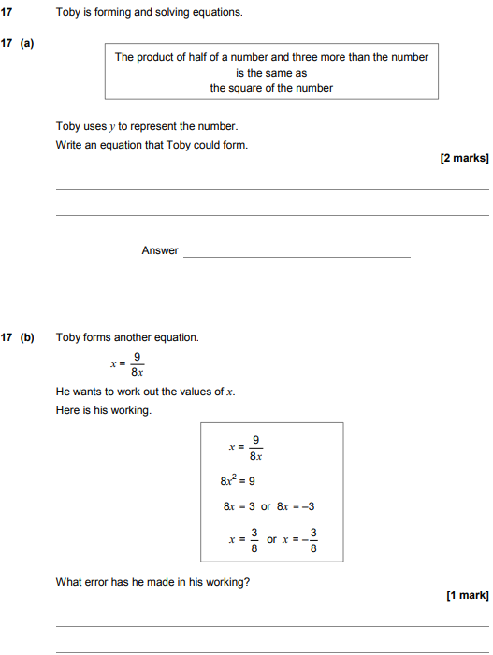

AQA GSCE – Tuesday 12 June 2018 – Paper 3 (Calculator) Higher Tier
5.
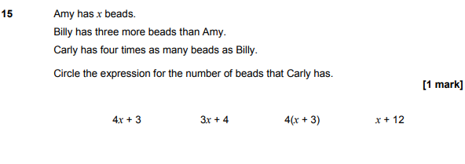
AQA GSCE – Thursday 2 November 2017 – Paper 1 (Non - Calculator) Higher Tier
6.
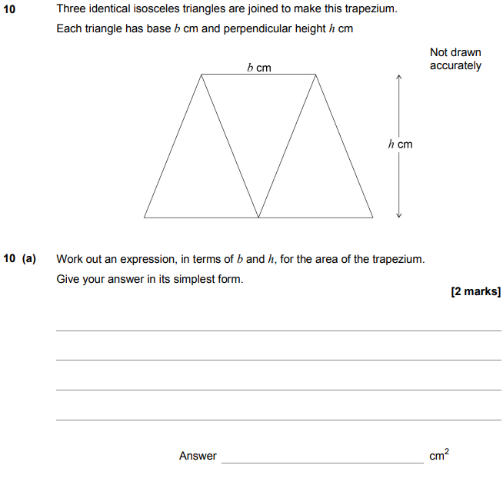
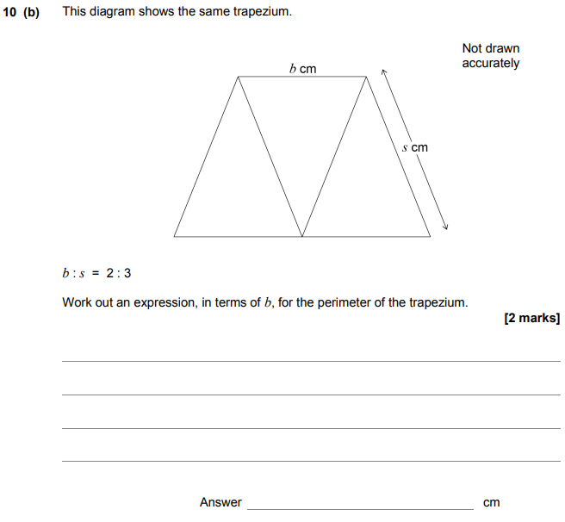

AQA GSCE – Thursday 8 June 2017 – Paper 2 (Calculator) Higher Tier
7.
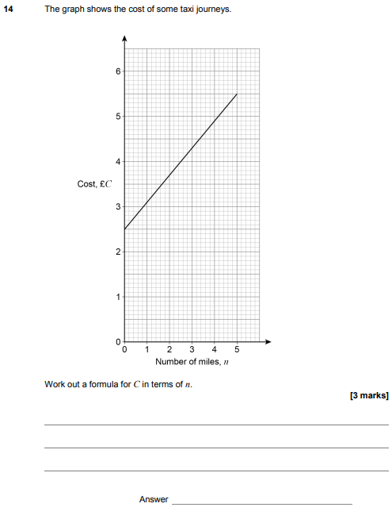

AQA GSCE – Sample Paper 1 (Non - Calculator) Higher Tier
8.
